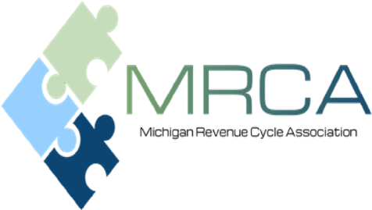

Dear Corporate Partner,
For over 30 years MPAA and MAHAP has provided speakers, industry updates, professional development and training resources to Patient Accounting and Revenue Cycle professionals, and MRCA will continue to do the same. MRCA has been a valuable source of education to the Michigan Revenue Cycle community, and we are excited for 2023. Our 2023 membership year will consist of in-person meetings, in-person networking opportunities, panel discussions, payer updates along with educational and motivational speakers.
As we look ahead to the 2023 program, we felt it appropriate to keep all the benefits of the 2022 corporate sponsorship program but include MRCA membership(s) based on the sponsorship level. The membership would be for a specified individual(s) named during the corporate sponsorship registration. We hope that this offers you the ability to join us for our meetings and meet with our members.
As a Corporate Sponsor you will benefit from:
- Networking opportunities with
- Decision makers from hospital billing and business offices throughout Michigan.
- Peers from corporations and organizations similar to yours.
- Recognition as an industry leader and supporter of MRCA’s professional development and program initiatives.
- Exposure to industry experts, quality speakers, healthcare billing and reimbursement trends.
- Value…providing maximum return on your sponsorship and marketing investment.
The enclosed form outlines the Corporate Sponsorship program and benefits provided for each level. Please consider becoming a Corporate Sponsor for 2023 by either renewing your sponsorship or becoming a Corporate Sponsor for the very first time. It is through your participation and support that we can continue to offer quality education and professional development to medical professional throughout the state.
As always, we appreciate your support and remind you that the program is invaluable for both our Corporate Partners and the MRCA membership.

Sincerely,

Robin Beeman
MRCA Sponsorship Co-Chair
586-876-5013
robin.beeman@meddata.com

Andrea Ronse
MRCA Sponsorship Co-Chair
443-886-4351
aronse@trendhealthpartners.com

Corporate Sponsorship Program 2023

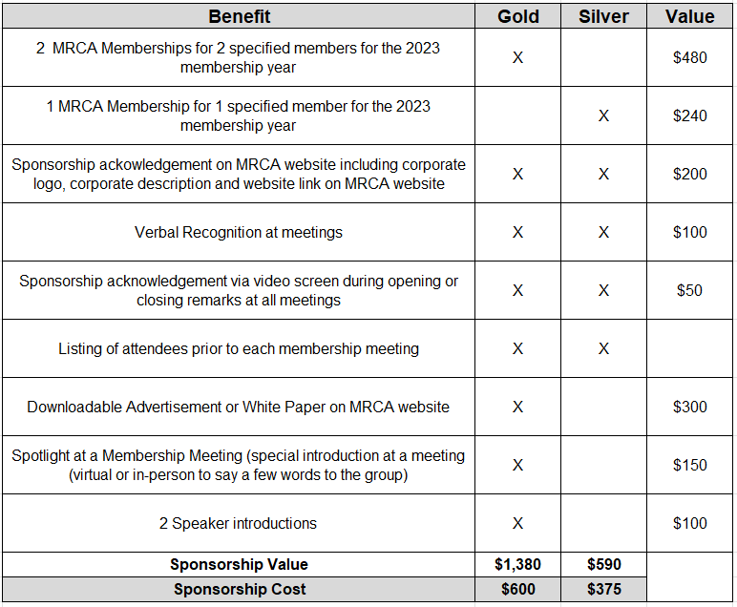

Additional Sponsorship Opportunities:
- Corporate logo, corporate description, and website link on MRCA website: $150.

Michigan Revenue Cycle Association
2023 Corporate Sponsors

Please CLICK HERE to register online!

Meeting dates for the 2023 year are listed below. All meetings will be in-person unless there are changes in the pandemic and/or State requirements.
- January 20, 2023 – Okemos, MI
- March 24, 2023 – Okemos, MI
- May 19, 2023 – Okemos, MI
- November 10, 2023 – Okemos, MI

Depending on the sponsorship level you choose, the following will be needed:

  - Website link
  - Logo – Please utilize *.JPG, *.GIF, or *.PNG as the format no larger than 320x100
  - Corporate description
  - For the gold sponsors, please also include the following:
    - Chosen advertisement or white paper – this can be in PDF format

Please complete form and mail to:

Robin Beeman
16472 Crosswind Lane
Macomb Township, MI 48042

Thank you for your generous support! Feel free to contact one of us if you have any questions or need additional information.

Robin Beeman
MRCA Sponsorship Chair Co-Chair
586-876-5013
robin.beeman@meddata.com

Andrea Ronse
MRCA Sponsorship Co-Chair
443-886-4351
aronse@trendhealthpartners.com

