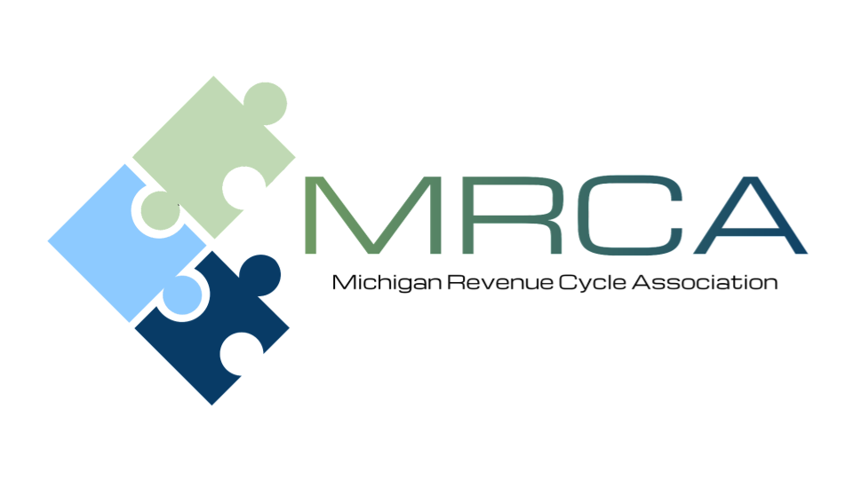

MEETING AGENDA
Please Join us!

Location: | Comfort Inn  2187 University Park Dr.  Okemos, MI 48864  (517) 347-6690
Date and Time: | Friday, March 20, 2026  9:00 AM – 3:00 PM

Please send your payer questions to
Kelly Jackson kjackson@memorialhealthcare.org
Patty Steele patricia.steele@trinity-health.org

8:30 am | Registration
9:00 am - 10:00 am | Advocacy Updates - Ben Frederick Associate Vice President of Advocacy & Government Relations, Memorial Healthcare
10:00 am -10:10 am | Break – Visit with Corporate Sponsors
10:10 am - 12:00 pm | Third Party Updates:  Confirmed  - BCBS (Leah Moore)  - McLaren (Darrian Colborne)  - JVHL (Baili Abate)  - Blue Cross Complete (Renee Price, Taniesha Snead)  - MDHHS (Danielle Vallejo)- No presentation  Pending confirmation  - United Health Care (Kirsten Shilling)  - Meridian  - Molina (Tania Mitchell)  - Aetna (Kiley Radel)  - HAP (Suzanne Kayner)
12:00 pm - 1:00 pm | Lunch and Networking
1:00 pm – 2:00 pm | OBBBA Is Coming: Are Your Financial Assistance Efforts Ready?  Nick McLaughlin, FHFMA, Founder and CEO, breez
2:00 pm - 3:00 pm | Navigating Legislative Changes related to Medicaid Eligibility and Enrollment.  Robin Beeman, AVP Client Strategy, and Ellen Tolley, Service Line Director, ELEVATE Patient Financial Solutions
SPEAKER INFORMATION

Nick McLaughlin, FHFMA
BREEZ

Nick McLaughlin is the Founder and CEO of Breez Health, a member of the Goodroot community of companies, dedicated to furthering the mission of delivering more accessible, patient-friendly financial assistance programs for hospitals across the US.

With over 12 years of experience working in hospital billing and revenue cycle, Nick has a deep understanding of the challenges facing hospitals and their patients. Early in his career, Nick was instrumental in helping hospitals craft financial assistance policies that met federal and state requirements like 501(r). Now, he works to bring a more patient-friendly approach to financial assistance that enables greater access and education to the patients while also alleviating the administrative burden for hospitals.

Nick is known throughout the industry for his passion, insights, and innovative ideas for delivering affordable healthcare.

OBBBA Is Coming: Are Your Financial Assistance Efforts Ready?
Come January, the new OBBBA is projected to leave 10–16 million more people uninsured as Medicaid work requirements, more frequent redeterminations, and ACA subsidy rollbacks take hold.

Hospitals will face a surge in patients requiring in-depth financial and coverage screening—stretching staff capacity, and increasing uncompensated care risk.

This presentation will give you the clarity and strategies you need to prepare before the wave hits.

What You’ll Learn:
- OBBBA’s key changes to Medicaid, ACA, and premium tax credits.
- How to prepare for higher financial counseling demand while limiting additional staff needs.
- Strategies to scale screenings and protect revenue.
- Who Should Attend:
  - This session is designed for revenue cycle, patient financial services, and patient access leaders who need to prepare for higher volumes, complex eligibility scenarios, and increased uncompensated care risk.
Robin Beeman, AVP of Client Strategy
Elevate Patient Financial Solutions

Robin Beeman serves as Associate Vice President of Client Strategy at Elevate Patient Financial Solutions. With more than 40 years of experience supporting hospitals and health systems, she brings extensive expertise in revenue‑generating initiatives across patient access, patient accounting, project management, eligibility services, collections, physician and provider relations, and customer service.
Throughout her distinguished career, Robin has demonstrated a strong track record of delivering exceptional customer service, building high‑performing teams, and consistently surpassing organizational goals. She has cultivated long‑standing client partnerships and led strategic marketing efforts that have contributed to significant growth and expanded service
capabilities across multiple markets. She brings deep expertise in resolving complex disputes and managing escalations, ensuring issues are addressed quickly and with integrity. Robin ensures full compliance with HIPAA and all contractual requirements, protecting organizational interests and client confidentiality. As a collaborative, solutions‑focused leader, she introduces innovative processes, reporting structures, and operational strategies that strengthen performance and support core business goals.
Based in Michigan, she enjoys outdoor activities and values time spent with her husband, family, and friends.

Ellen Tolley, Service Line Director
Elevate Patient Financial Solutions

Ellen Tolley serves as Service Line Director at Elevate Patient Financial Solutions. She is a seasoned healthcare leader with 24 years of industry experience, including 15 years in progressive leadership roles. Committed to strengthening operational performance, she elevates team effectiveness to enhance the patient experience. With a bachelor’s degree in business focused on healthcare administration; she brings a strategic, yet people centered approach. She balances organizational efficiency with thoughtful, empathetic leadership. Ellen is known for her collaborative style, integrity, and ability to create supportive environments where teams feel empowered to excel. She is driven by the challenge of
navigating complex healthcare systems and developing solutions that positively impact both staff and the communities they serve.
A Michigan native, Ellen loves exploring trails with her four-legged companion, discovering new travel destinations, cheering at sporting events, and embracing any water-based adventure. She channels that same energy, curiosity, and commitment to growth into her professional life, continually learning, adapting, and striving to make a meaningful difference.

Navigating Legislative Changes related to Medicaid Eligibility and Enrollment
Session Description:
Review of recent Medicaid updates, including changes to Medicaid funding and coverage requirements related to the One Big Beautiful Bill Act (OBBBA). Strategies to effectively navigate and minimize the negative impact of these changes will also be discussed.

Learning Objectives:
· Overview of the current legislation and its impact on Medicaid eligibility and enrollment
· How health systems and their patients will be affected by this change
· Best practices to mitigate the impact

MEETING REGISTRATION INFORMATION
Register Here
(Even if paying by check)
Please register by March 13, 2026
MRCA Member’s cost: FREE
Non-Member’s cost: $100

As an MRCA member, there is no charge for regular meetings. We encourage guests to attend; however, there is a charge of $100.00 per guest.

Guests can register in advance and pay online through the link above, pay by check at the meeting, or mail to McLaren Central Michigan 1221 South Drive, Attn: Renee Sheneman, Compliance Department Mt. Pleasant, MI 4858. Make checks payable to: MRCA

