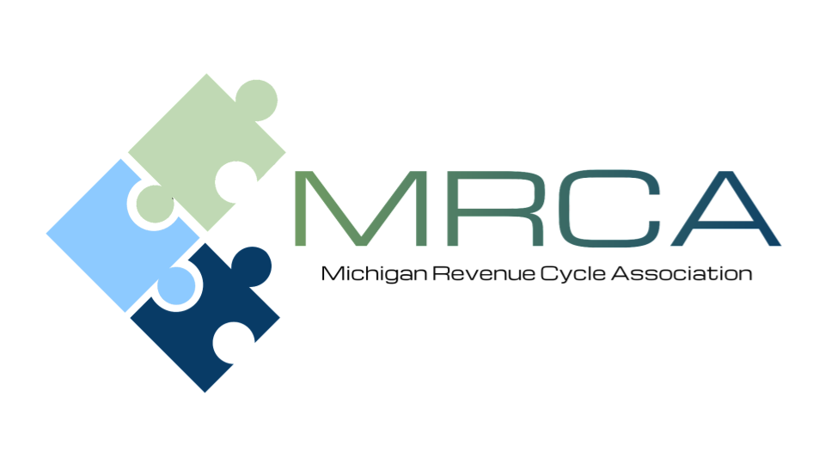

MEETING AGENDA
Please Join us!

Location: | Comfort Inn  2187 University Park Dr.  Okemos, MI 48864  (517) 347-6690
Date and Time: | Friday, November 7, 2025  9:00 AM – 2:00 PM

Welcome to the final Membership Meeting of 2025

Please send your payer questions to
Kelly Jackson kjackson@memorialhealthcare.org
Patty Steele patricia.steele@trinity-health.org
8:30 am | Registration
9:00 am - 10:00 am | MHA updates: Megan Blue, Senior Director, Health Care Policy
10:00 -10:10 | Break – Visit with Corporate Sponsors
10:10 -11:30 pm | Third Party Updates:  - U of M Health Plan (Bethany Dumond) - confirmed  - BCBS (Leah Moore) - confirmed  - McLaren (Ken Axtell) - confirmed  - MDHHS (Danielle Vallejo) - confirmed  - Blue Cross Complete (Pat Embry) – confirmed  - JVHL (Baili Abate) - confirmed  - Coventry – unavailable  - HAP – unavailable  - Priority Health - unavailable  - United Health Care - unconfirmed  - Aetna – unconfirmed  - Meridian – unconfirmed  - Molina - unconfirmed
11:30 -12:15 pm | WPS updates (virtual presentation) - Aileen Siegler
12:15 -1:00 pm | Lunch and Networking
1:00 pm - 2:00 pm | Back by Popular Demand “Authorization System Demo”- Patrice Olivio – Veteran’s Administration Billing Liaison
2:00 PM | Closing
SPEAKER INFORMATION

Patrice Olivio is a Billing Liaison Program Specialist at the Veterans Administration and has been with the VA for nine years, six of which have been in Community Care. She holds a bachelor's degree in healthcare administration. Patrice has two children and five grandchildren, who are the center of her world.
Patrice will provide a brief overview of VA claims requirements and will be glad to answer questions and address audience concerns.

MEETING REGISTRATION INFORMATION
Register Here
(Even if paying by check)
Please register by October 31, 2025
MRCA Member’s cost: FREE
Non-Member’s cost: $75

As an MRCA member, there is no charge for regular meetings. We encourage guests to attend; however, there is a charge of $75.00 per guest.

Guests can register in advance and pay online through the link above, pay by check at the meeting, or mail to McLaren Central Michigan 1221 South Drive, Attn: Renee Sheneman Compliance Department Mt. Pleasant, MI 4858. Make checks payable to: MRCA
Registration Coming Soon for 2026 Membership Year



