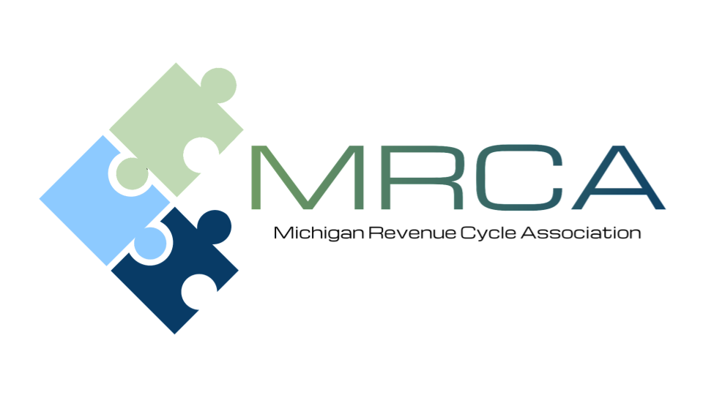

MEETING AGENDA
Please Join us!

Location: | Comfort Inn  2187 University Park Dr.  Okemos, MI 48864  (517) 347-6690
Date and Time: | Friday, January 23, 2026  9:00 AM – 3:00 PM

Welcome to the first Membership Meeting of 2026

Please send your payer questions to
Kelly Jackson kjackson@memorialhealthcare.org
Patty Steele patricia.steele@trinity-health.org
Wendy Abbott wendy.abbott@umhsparrow.org

8:30 am | Registration
9:00 am - 10:00 am | MHA updates: Megan Blue, Senior Director, Health Care Policy  Alex Seasock, Government Relations Specialist, through a coalition of team members. (Memorial Healthcare)
10:00-10:10 am | Break – Visit with Corporate Sponsors
10:10 -12:00 pm | Third Party Updates:  Confirmed  - BCBS (Leah Moore)  - Aetna (Kiley Radel)  - HAP (Suzanne Kayner)  - McLaren (Darrian Colborne)  - Blue Cross Complete (Renee Price)  - United Health Care (Kirsten Shilling)  - JVHL (Baili Abate)  Pending confirmation  - MDHHS (Danielle Vallejo)  - Meridian (Allis Leas)  - Molina (Tania Mitchell)  - VA (Patrice Olivio)
12:00-1:00 pm | Lunch and Networking
1:00 pm - 2:00 pm | Breez: OBBBA Is Coming: Are Your Financial Assistance Efforts Ready?  Nick McLaughlin FHFMA
2:00 pm - 3:00 pm | Blue and Co – Denial Management and Prevention, Let’s Flip the Script. Jonathan Hendricks, Senior Consultant
3:00 pm - 3:15 pm | Closing
SPEAKER INFORMATION

Nick McLaughlin, FHFMA
BREEZ

Speaker Bio:

Nick McLaughlin is the Founder and CEO of Breez Health, a member of the Goodroot community of companies, dedicated to furthering the mission of delivering more accessible, patient-friendly financial assistance programs for hospitals across the US.

With over 12 years of experience working in hospital billing and revenue cycle, Nick has a deep understanding of the challenges facing hospitals and their patients. Early in his career, Nick was instrumental in helping hospitals craft financial assistance policies that met federal and state requirements like 501(r). Now, he works to bring a more patient-friendly approach to financial assistance that enables greater access and education to the patients while also alleviating the administrative burden for hospitals.

Nick is known throughout the industry for his passion, insights, and innovative ideas for delivering affordable healthcare.

OBBBA Is Coming: Are Your Financial Assistance Efforts Ready?
Come January, the new OBBBA is projected to leave 10–16 million more people uninsured as Medicaid work requirements, more frequent redeterminations, and ACA subsidy rollbacks take hold.

Hospitals will face a surge in patients requiring in-depth financial and coverage screening—stretching staff capacity, and increasing uncompensated care risk.

This presentation will give you the clarity and strategies you need to prepare before the wave hits.

What You’ll Learn:
- OBBBA’s key changes to Medicaid, ACA, and premium tax credits.
- How to prepare for higher financial counseling demand while limiting additional staff needs.
- Strategies to scale screenings and protect revenue.
- Who Should Attend:
  - This session is designed for revenue cycle, patient financial services, and patient access leaders who need to prepare for higher volumes, complex eligibility scenarios, and increased uncompensated care risk.

Jonathan Hendricks, CRCR
Senior Consultant Blue and Co.

Speaker Bio:

Jonathan Hendricks is a Senior Consultant with Blue & Co., LLC’s Revenue Cycle Team. Jonathan has more than 25 years of experience in revenue cycle services that extend from pre-access/patient registration through A/R resolution. He has worked in both profit and not-for-profit hospital settings, revenue cycle technology space as well as a consultant for ICD-10 preparedness.
Jonathan works with all levels of leaders to assess current operations, identify areas of opportunity, strategize on logical/attainable plans, which then allows for actions to be set into motion for improvements. Areas of focus and expertise include patient access, charge capture, billing (pre/post), cash posting, A/R management, denial prevention as well as payer credentialing. Jonathan is experienced with PPS/CAH/LTAC hospital reimbursement along with EMS, HH, DME and professional billing operations.

Denial Management Prevention – Lets Flip the Script
Everywhere you turn within the healthcare financial realm, denials and how to manage them seem to be the top discussion points for most providers. If you have been in the industry long enough, you realize that claim denials and reimbursement challenges are greater than ever before and appear to have no end in sight. Dealing with claim denials can feel daunting and overwhelming for finance leaders and their dedicated staff that are battling at the account level, day-in and day-out. Proactive steps are the first line of defense to ensure that denials are reduced or avoided downstream. Reactive steps should be designed and acted upon timely to secure as much revenue as possible and decrease the need for write-offs. Being deliberate in reviewing trends and habits of the overall Revenue Cycle will allow for better performance and overall health of the financial well-being of the organization.

In this session, attendees will learn about the current hot button denial issues and come away with strategies and techniques to combat and reduce denials.

Learning Objectives:
1. Identify top issues and trends in denials
2. Execute workflow and process improvements to tackle existing denials
3. Take steps to reduce future denials

MEETING REGISTRATION INFORMATION
Register Here
(Even if paying by check)
Please register by January 16, 2026
MRCA Member’s cost: FREE
Non-Member’s cost: $100

As an MRCA member, there is no charge for regular meetings. We encourage guests to attend; however, there is a charge of $100.00 per guest.

Guests can register in advance and pay online through the link above, pay by check at the meeting, or mail to McLaren Central Michigan 1221 South Drive, Attn: Renee Sheneman, Compliance Department Mt. Pleasant, MI 4858. Make checks payable to: MRCA
Register Now for 2026 Membership Year

