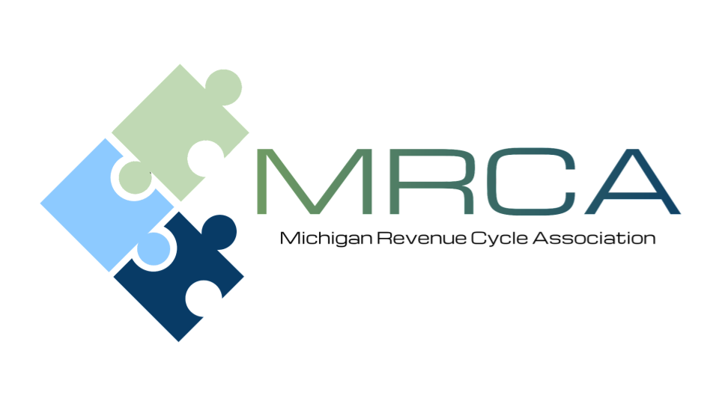

MEETING AGENDA
Please Join us!

Location: | Teams Meeting
Date and Time: | Friday, May 15, 2026  9:00 AM – 11:00 AM

Please send your payer questions to
Kelly Jackson kjackson@memorialhealthcare.org
Patty Steele patricia.steele@trinity-health.org

9:00 am | Welcome – MRCA Updates
9:05 am - 10:00 am | Third Party Updates:  - BCBS (Leah Moore) (Sonya Lewis) Confirmed  - JVHL (Baili Abate) Confirmed  - Coventry (Jennifer Crane) Confirmed  - Blue Cross Complete (Renee Price, Taniesha Snead) Confirmed  - MDHHS (Danielle Vallejo)- Confirmed  - Molina (Tania Mitchell) Pending Confirmation  - Aetna (Kiley Radel) Pending Confirmation  - HAP (Suzanne Kayner) Unavailable  - Priority Health (Mike Dembrowski) Unavailable  - McLaren (Darrian Colborne) Unavailable  - United Health Care (Jacquelyn Jarrett) Unavailable
10:00 am – 11:00 am | Noel Dean – High School football head coach, educator, and mentor. The Unintended Awesomeness of a Giving Mindset

SPEAKER INFORMATION
Noel Dean
Noel Dean is more than a championship football coach — he is a builder of people, programs, and communities. Over more than three decades as a head coach, educator, and mentor, Dean has led teams to multiple state championships while shaping generations of young athletes into confident leaders. Known for building winning cultures from the ground up, his programs emphasize discipline, accountability, and belief to achieve success on and off the field.
Dean’s impact extends far beyond the scoreboard. Through community initiatives and “cause games,” most notably the nationally recognized Pink Arrow Pride Game, he has used football as a platform to unite communities, support families battling cancer, and teach players the importance of serving something bigger than themselves.
The same values he teaches have shaped his own family. All four of Dean’s children were college athletes — including three sons who graduated from Harvard University and a daughter who played soccer at Ferris State University and now attends Michigan State University’s College of Human Medicine. These experiences as both a coach and father give him a unique perspective on developing young people and raising resilient, high-character leaders.
As a motivational speaker, Dean shares lessons from the locker room, classroom, and community about leadership, character, and overcoming adversity. His message inspires coaches, educators, parents, and athletes to build stronger cultures and invest in the next generation.
The Unintended Awesomeness of a Giving Mindset
Noel will remind us in a numbers-driven healthcare environment, it is essential to remember that people remain at the heart of the work we do. Beyond improving the health of those we serve, adopting a positive, non-transactional mindset can also enhance the experience of those providing care and support. When we focus on human connection rather than purely transactional interactions, our work becomes more meaningful and enjoyable. He will draw on personal experiences from a patient and consumer perspective — particularly a life-changing childhood illness—as well as from community-building efforts like the Pink Arrow Pride Project. Through relatable, real-life examples, He will connect these experiences back to our needs and the value of keeping people at the center of healthcare.

MEETING REGISTRATION INFORMATION
Register Here
(Even if paying by check)

Join the May 15, 2026 MRCA Teams Meeting Here
Please register by May 14, 2026
MRCA Member’s cost: FREE
Non-Member’s cost for Virtual Meeting: $50

As an MRCA member, there is no charge for regular meetings. We encourage guests to attend; however, there is a charge of $50.00 per guest for this virtual meeting.

Guests can register in advance and pay online through the link above, pay by check at the meeting, or mail to McLaren Central Michigan 1221 South Drive, Attn: Renee Sheneman, Compliance Department Mt. Pleasant, MI 4858. Make checks payable to: MRCA



